
B-Raf (V600D)
Catalog Number: CR-M26184
Gene Symbol: BRAF, BRAF1, RAFB1
Description: Anti-B-Raf (V600D) Mouse Monoclonal Antibody

Background: B-Raf is a member of the Raf family of Ser/Thr protein kinases. It functions downstream of Ras to regulate the MAP kinase signaling pathway. Mutations in the BRAF gene cause diseases. Inherited mutations in BRAF cause cardiofaciocutaneous syndrome. Acquired mutations in BRAF have been found in cancers.
Immunogen: A synthetic peptide from the internal region of B-Raf (V600D), human origin. Tested applications: ELISA, WB, IF, IHC
Recommended dilutions:
ELISA 1:1000-1:5000
WB 1:500-1:2000
IHC 1:100-1:200
Concentration: 0.5 mg/ml
Host: Mouse
Clonality: Monoclonal
Isotype: IgG
Purity: Purified from ascites
Format: Liquid Storage buffer:
Preservative: no
Constituents: PBS (without Mg2+ and Ca2+), pH 7.4, 150 mM NaCl, 50% glycerol
Species Reactivity: Recognizes V600D mutated, but not wild-type B-Raf proteins from
vertebrates.
Storage Conditions: Store at -20°C. Avoid freeze / thaw cycles.

Western blot:

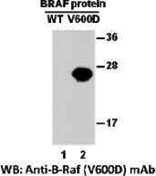

Western blot analysis of recombinant B-raf proteins. Purified His-tagged B-Raf (V600D) protein (amino acids 513-693, lane 2) and corresponding wild type protein (lane 1) were blotted with anti-B-Raf (V600D) monoclonal antibody (Cat. # 26184).

For research use only. Not for diagnostic or therapeutic applications.

Immunofluorescence:
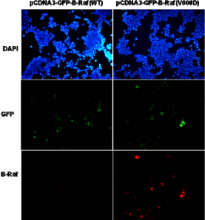
Immunofluorescence of cells expressing B-Raf proteins with anti-B-Raf (V600D) antibody.
HEK293T cells were transfected with
pCDNA3-GFP-B-Raf (WT) plasmid (left column) or pCDNA3-GFP-B-Raf (V600D) plasmid (right column), then fixed and stained with anti-B-Raf (V600D) monoclonal antibody (Cat. #26184).

科博瑞（武汉）生物科技有限公司
TEL：027-87615885 15972062685
- mail：3636901710@qq.com
Web:www.coburybio.com

For research use only. Not for diagnostic or therapeutic applications.

